Year 12 Chemistry Topic Test #3 - 2011

Name: ANSWERS Mark = _____ / 57

Part 1: Multiple Choice Section 10 marks
______________________________________________________________________________

1. D 2. C 3. A 4. C 5. B 6. B 7. A 8. C 9. A 10. A

Part 2: Short Answer Section 47 marks
______________________________________________________________________________

11. Name and draw full structural formula to represent the following substances;

A saturated isomer of C₄H₈ |  | 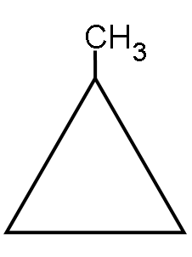
 | cyclobutane | methylcyclopropane
An alkene with 4 carbon  atoms that does not exhibit  geometric (cis/trans) isomerism | 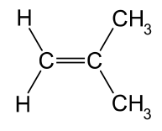 | 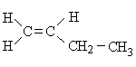
 | methylpropene | 1-butene
Tthe product of reacting
cis-pent-2-ene with hydrogen

 | pentane
A structural isomer of
methyl methanoate that fizzes when added to sodium carbonate solution
 | ethanoic acid
An amine with 5 hydrogen atoms | 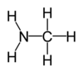
 | methanamine
The organic product formed when  one molecule of cyclohexane  reacts with one molecule of chlorine  in the presence of UV light | 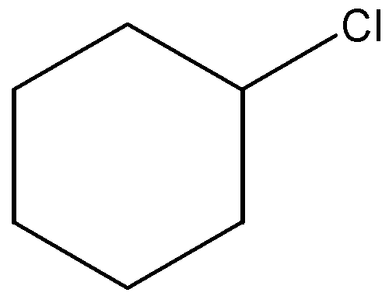
 | chlorocyclohexane

each (12 marks)
12. Complete the following table.

Molecule | Major type of intermolecular attraction  (choose from dispersion forces,  dipole-dipole or hydrogen bonding) | Boiling point ranking  (1 = highest, 5 = lowest)
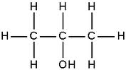 | hydrogen bonding | 2
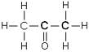 | dipole-dipole forces | 3
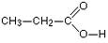 | hydrogen bonding | 1
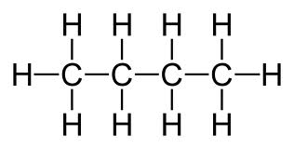 | dispersion forces | 4
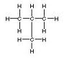 | dispersion forces | 5

each (8 marks)

13. The structures of glycine and alanine are shown below:

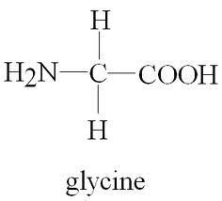 | 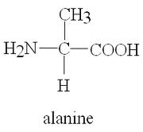

(a) To which class of compounds do they both belong?

Amino acids
(1 mark)

(b) What is the main intermolecular force between alanine molecules?

Hydrogen bonding

(1 mark)

(c) A glycine molecule and an alanine molecule can react with each other in a
condensation reaction to form a new substance called a dipeptide.

Draw one of the two possible dipeptides that could be formed below.

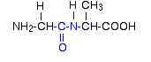 | 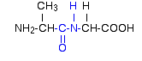

(3 marks)
14. There are four isomeric alcohols, all of which have the molecular formula, C₄H₁₀O.

Draw each of these alcohols, and draw their oxidation product(s) when reacted with
acidified potassium dichromate solution.

Alcohol | Oxidation product(s)
CH₃CH₂CH₂CH₂OH  (1-butanol) | CH₃CH₂CH₂CHO | CH₃CH₂CH₂COOH
CH₃CH₂CHOHCH₃  (2-butanol) | CH₃CH₂COCH₃
CH₃CH(CH₃)CH₂OH  (methyl-1-propanol) | CH₃CH(CH₃)CHO | CH₃CH(CH₃)COOH
CH₃CH(OH)(CH₃)CH₃  (methyl-2-propanol) | none

each (10 marks)

15. 2.19 g of an organic compound X is completely burnt in excess oxygen, forming 3.21 g of
carbon dioxide and 1.32 g of water.

(a) Calculate the empirical formula of X.

C | H | O
m(C) = $\frac{12.01}{44.01}$ x m(CO₂)  = 0.876 g | m(H) = $\frac{2.016}{18.016}$ x m(H₂O)  = 0.148 g | m(O) = 2.19 – m(C) – m(H)  = 1.166 g
n(C) = 0.876 / 12.01  = 0.0729 | n(H) = 0.148 / 1.008  = 0.1465 | n(O) = 1.166 / 16  = 0.0729
0.0729
1 | 2 | 1

∴ EF = CH₂O

(7 marks)

In a second experiment it was found that 0.473 g of X occupied 278 mL (= 0.278 L),
measured at 200ºC (= 473.1 K) and 1.10 atm ( = 1.10/1 x 101.3 = 111.4 kPa).

(b) Calculate the molecular formula of the compound.

n = PV/RT = (111.4 x 0.278)/(8.315 x 473.1) = 0.00787 mol

M = m/n = 0.473 / 0.00787 = 60.1 g mol^{–1}

M/EFM = 60.1 / 30.026 ≈ 2

∴ MF = 2 x EF = C₂H₄O₂

(3 marks)

(c) Given that, at STP, X is a sweet smelling liquid, draw the structural formula of
X and name it.

∴ ester

methyl methanoate

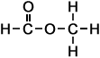

(2 marks)

End of Test

